Session 11: Sqoop Flume

Assignment

1 Question

*Session 11: Assignment 1*

**Table of Contents**

1. Introduction

2. Problem Statement

3. Output

**1. Introduction**

This assignment will help you to consolidate the concepts learnt in the session.

**2. Problem Statement**

**Problem Statement:**

Perform and explain the code flow and the associated result for the below tasks. Candidates should

create and use their own employee dataset for the same. Share the screenshot of the commands used

and its associated result.

N/A

● Transfer data between Mysql and HDFS (Import and Export) using Sqoop.

● Transfer data between Mysql and Hive (Import and Export only selected columns) using Sqoop.

**3. Output**

**Transfer data between Mysql and HDFS (Import and Export) using Sqoop.**

* Starting MySQL as root user/mode

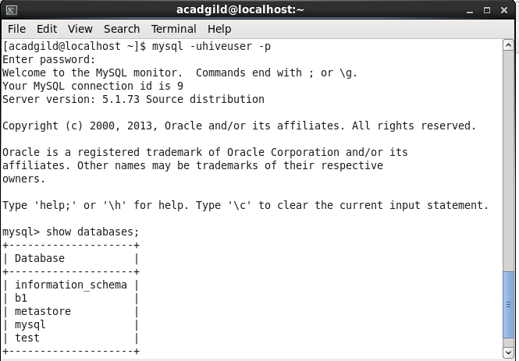





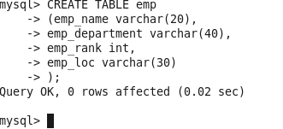

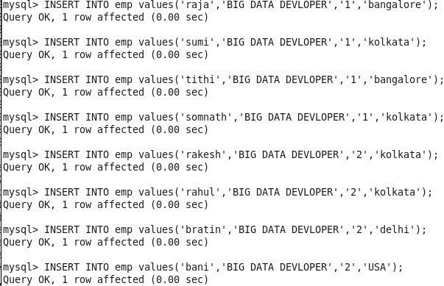

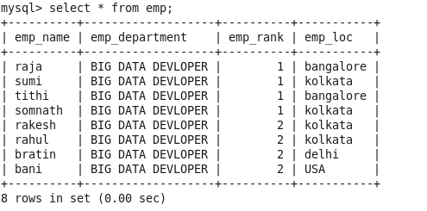

Transfer the data from MySQL table to a HDFS Location, we use the Sqoop **import** command

sqoop import --connect jdbc:mysql://localhost/forSqoop --table emp --username hiveuser -P --target-dir /sqoopout -m 1

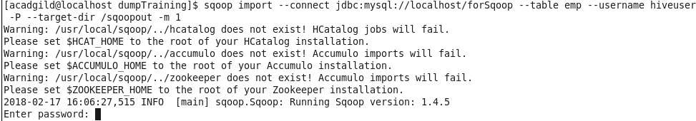

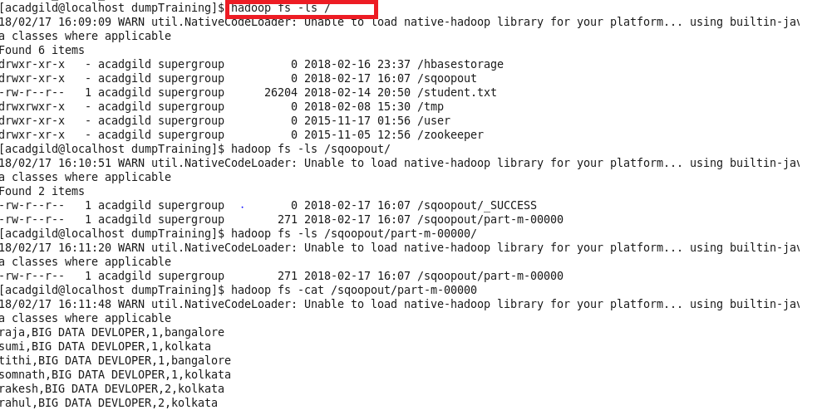

Transfer data between Mysql and Hive (Import and Export only selected columns) using Sqoop.

* Starting the MySQL service (Needed for hive)
* Starting Hive

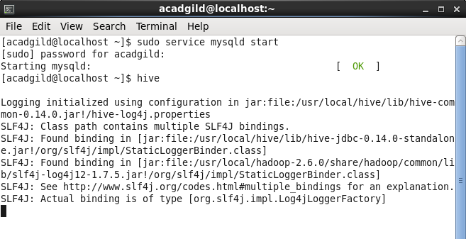

To transfer the data from the from the MySQL table to a Hive table, we use the Sqoop **import** command

